**UFRO - AUT JOINT INNOVATION FUND 2024**

**APPLICATION FORM**

**BACKGROUND OF THE PARTICIPANTS**

|  |  |
| --- | --- |
| NAME OF RESPONSIBLE PERSON UFRO: |  |
| Position: |  |
| Faculty / Department: |  |
| Email Address: |  |

|  |  |
| --- | --- |
| NAME OF RESPONSIBLE PERSON AUT: |  |
| Position: |  |
| Faculty / Department: |  |
| Email Address: |  |

**1) PROPOSAL IDENTIFICATION**

|  |
| --- |
| **TITLE OF THE PROPOSAL** |
| *(Maximum 350 characters including spaces)* |

|  |  |
| --- | --- |
| Project Duration (Number of Months) |  |
| Project Type (Public or Private Interest) |  |
| Initial TRL (Appendix 1) |  |
| Final TRL (Appendix 1) |  |
| Requires Ethics Committee Certificate (Yes / No) |  |
| 3 Keywords |  |
| Thematic Areas SDGs (If is Applicable) (According to Appendix 2) |  |
| OECD Discipline (According to Appendix 3) |  |

|  |
| --- |
| **EXECUTIVE SUMMARY** |
| *(Maximum 1,200 characters, including spaces)*  *Describe briefly the problem or opportunity targeting on the proposal, and indicate the proposed scientific-technological solution.* |

**2) PROJECT OVERVIEW**

|  |
| --- |
| **PROBLEM, OPPORTUNITY, OR CHALLENGE** |
| *(Maximum 2,000 characters, including spaces)*  *Indicate the problem, opportunity or challenge, and his scientific and technological relevance and current importance. Include an estimated quantification of the problem or opportunity in this analysis.* |

|  |
| --- |
| **THEMATIC AREAS (IF REQUIRED)** |
| *● Indigenous Futures and co-creating partnerships with communities*  *● Enhancing tourism and digital technologies*  *● Agriculture technologies*  *● Affordable and sustainable housing* |

|  |
| --- |
| **DESCRIPTION OF THE INTERESTED INSTITUTION** |
| *(Maximum 1,000 characters, including spaces)*  *Provide a brief description of the Partner institution and its contribution to the problem or opportunity identified. (Support letter format in Appendix 4)* |

|  |
| --- |
| **PROPOSED SOLUTION** |
| *(Maximum 3,500 characters, including spaces) Clearly describe the proposed solution, which may be presented in the form of products, processes, or services, such as validated protocols, tools and work methodologies, procedure manuals, development and validation of assessment instruments, among others, that could be obtained in the future if the research/development line continues.* |

|  |
| --- |
| **PREVIOUS RESULTS** |
| *(Maximum 2,000 characters, including spaces) Include the previous results of research and technological development that support your project. These may be in the public domain or protected; In case of using research and development results that are protected by intellectual property, the beneficiary must take all the necessary safeguards to use them during the execution of the project.* |

|  |
| --- |
| **STATE OF THE ART ANALYSIS** |
| *(Maximum 3,500 characters, including spaces) Carry out a review of what is being investigated in terms of the subject under study and the existing approaches, focusing on the latest research carried out and advances in this matter.* |

**3) WORK PLAN**

|  |
| --- |
| **SCIENTIFIC HYPOTHESIS AND RESEARCH COMPONENT** |
| *State the scientific and/or technological hypothesis that this project aims to address. These should be hypotheses regarding the application of a product, process, or service, which will be validated through the development of a small-scale prototype during the research.* |

|  |
| --- |
| **OBJECTIVES AND RESULTS** |
| *General objective: State the main goal of the project, outlining its overall purpose and direction. It should be broad, guiding the specific objectives and reflecting the key outcome to be achieved.*  *Specific Objectives of the Project:*  *Add the specific objectives required (maximum of 5). These should be contained within the general objective.*  *Expected Result(s):*  *The expected result(s) should correspond to a means of verifying the anticipated technical progress to be achieved within the framework of the project.* |

|  |
| --- |
| **RESEARCH AND DEVELOPMENT METHODOLOGY** |
| *(Maximum 7,000 characters, including spaces)*  *The research and development methodologies should align with the nature of a scientific or technological research project or experimental development, and must include all necessary components for testing the hypothesis and achieving the intended production result. Indicate whether the associated entity/entities will participate in any of the proposed activities.*  *Include diagrams, drawings, schemes, or other materials that help to better understand the proposed methodology (if needed).* |

|  |
| --- |
| **ACTIVITIES AND GANTT CHART** |
| |  |  |  |  |  |  |  |  |  |  |  |  |  |  | | --- | --- | --- | --- | --- | --- | --- | --- | --- | --- | --- | --- | --- | --- | | Activity | Responsible | Month 1 | Month 2 | Month 3 | Month 4 | Month 5 | Month 6 | Month 7 | Month 8 | Month 9 | Month 10 | Month 11 | Month 12 | |  |  |  |  |  |  |  |  |  |  |  |  |  |  | |  |  |  |  |  |  |  |  |  |  |  |  |  |  | |  |  |  |  |  |  |  |  |  |  |  |  |  |  | |  |  |  |  |  |  |  |  |  |  |  |  |  |  | |

|  |
| --- |
| **BUDGET** |
| |  |  |  | | --- | --- | --- | | **UFRO Budget Item** | **Amount** | **Total Budget Item** | | *Specialized Services* |  |  | | *Technological Services* | $ 000.000 | $ 000.000 | | *Mobility* | $ 000.000 | | *Materials and Suppli* | $ 000.000 | | *Equipment Rental* | $ 000.000 | | *Intellectual Property Expenses* | $ 000.000 | | *Certification* | $ 000.000 | | *Other* | $ 000.000 | |  | $ 000.000 |  |  |  |  | | --- | --- | --- | | **AUT Budget Item** | **Amount** | **Total Budget Item** | | *Specialized Services* |  | $ 000.000 | | *Technological Services* | $ 000.000 | | *Mobility* | $ 000.000 | | *Materials and Supply* | $ 000.000 | | *Equipment Rental* |  | | *Intellectual Property Expenses* | $ 000.000 | | *Certification* | $ 000.000 | | *Other* | $ 000.000 | |  |  |  | | **TOTAL** |  | $ 000.000 | |

|  |
| --- |
| **RESEARCH TEAM** |
| *Incorporate the members of the research team, and the hours dedicated to the project.*  *(Research Gate - Google Scholar)*  **Project Director AUT:** Researcher Portal Link:  **Project Director UFRO:** Researcher Portal Link:  **Researcher 1:** Researcher Portal Link:  **Researcher 2:** Researcher Portal Link: |

|  |  |  |
| --- | --- | --- |
|  |  |  |
| Director's Signature |  | Signature of Alternate Director |

**ANNEX 1: Scale for Classifying Technology Readiness Level (TRL)**

This scale is used to assess the maturity level of a particular technology. Each technology project can be analyzed and categorized according to the parameters of each technology level, and then assigned a rating based on the technological progress of the research outcome. In summary, there are 9 levels, ranging from basic principles of the new technology to successful testing in a real environment:

**TRL 1 - Basic Principles Observed:**  
This is the lowest level of technological maturity. Basic scientific research begins. The transition to applied research starts. At this stage, there is no commercial application yet.

**TRL 2 - Technology Concept Formulated:**  
At this stage, potential applications of the technology and analytical tools for simulation or analysis may start to be formulated. However, there are still no tests or analyses validating the application.

**TRL 3 - Experimental Proof of Concept:**  
This phase includes conducting research and development (R&D) activities, including analytical tests and lab-scale experiments aimed at demonstrating the technical feasibility of the technological concepts. This phase involves validating the components of a specific technology, though this does not yet lead to the integration of all components into a complete system.

**TRL 4 - Technology Validated in Laboratory:**  
At this stage, the components that make up a technology have been identified, and the goal is to establish if these individual components have the capability to function together in a system.

**TRL 5 - Technology Validated in Relevant Environment:**  
The basic elements of the technology are integrated so that the final configuration is similar to its final application. However, the system and technologies are still operational at the laboratory level.

**TRL 6 - Technology Demonstrated in Relevant Environment:**  
At this stage, pilot prototypes capable of performing all necessary functions within a specific system may be available, having passed feasibility tests under real operating conditions. Components and processes may have been scaled up to demonstrate their industrial potential in real systems.

**TRL 7 - System or Prototype Demonstrated in Operational Environment:**  
The system is at or near operating at a pre-commercial scale. It is possible to conduct manufacturing-related aspects, life cycle assessment, and economic evaluation of the technologies, with most functions available and tested.

**TRL 8 - Complete System and Certified through Testing and Demonstrations:**  
At this stage, technologies have been tested in their final form and under operational conditions, often reaching the end of system development.

**TRL 9 - Actual System Proven in Real Operational Environment:**  
Technology/system in its final phase, proven and available for commercialization and/or production.

**ANNEX 2. Sustainable Development Goals (SDGs)**

For more information on the SDGs, visit the following link:

<https://sdgs.un.org/goals>

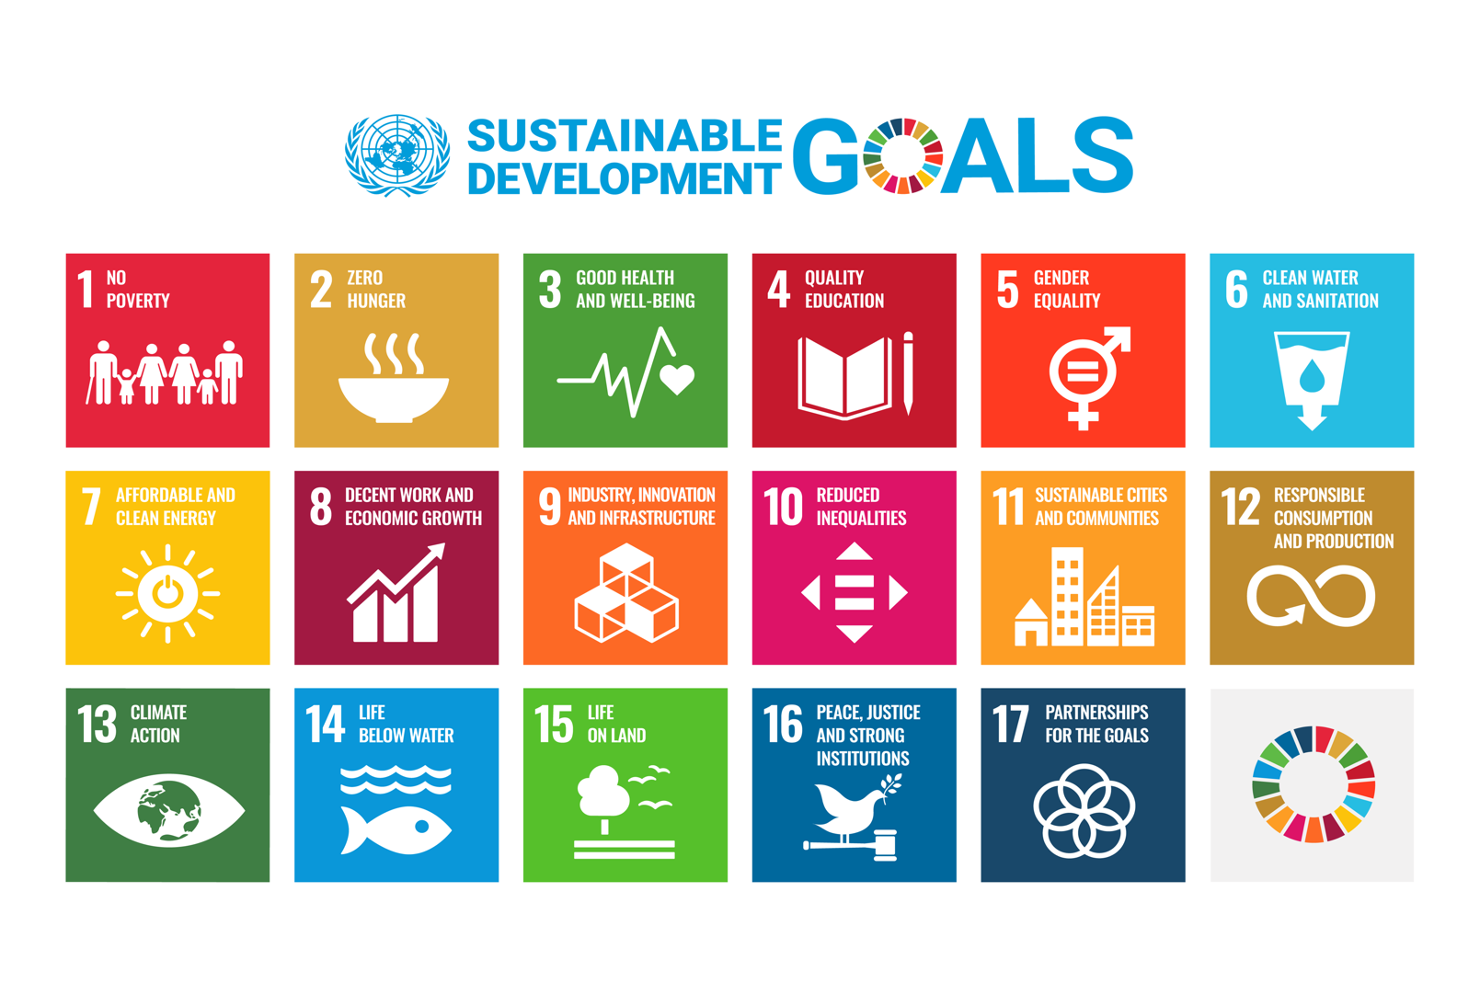

**ANNEX 3. List of OECD Disciplines and Areas of Knowledge according to the Frascati Manual**

|  |  |  |  |
| --- | --- | --- | --- |
| **Disciplines** | | **Field of knowledge** | |
| 1 | NATURAL SCIENCES | 1.1 | MATHEMATICS |
| 1 | NATURAL SCIENCES | 1.2 | COMPUTER SCIENCE AND INFORMATION SCIENCE |
| 1 | NATURAL SCIENCES | 1.3 | PHYSICAL SCIENCES |
| 1 | NATURAL SCIENCES | 1.4 | CHEMICAL SCIENCES |
| 1 | NATURAL SCIENCES | 1.5 | EARTH AND ENVIRONMENTAL SCIENCES |
| 1 | NATURAL SCIENCES | 1.6 | BIOLOGICAL SCIENCES |
| 1 | NATURAL SCIENCES | 1.7 | OTHER NATURAL SCIENCES |
| 2 | ENGINEERING AND TECHNOLOGY | 2.1 | CIVIL ENGINEERING |
| 2 | ENGINEERING AND TECHNOLOGY | 2.2 | ELECTRICAL, ELECTRONIC, AND COMPUTER ENGINEERING |
| 2 | ENGINEERING AND TECHNOLOGY | 2.3 | MECHANICAL ENGINEERING |
| 2 | ENGINEERING AND TECHNOLOGY | 2.4 | CHEMICAL ENGINEERING |
| 2 | ENGINEERING AND TECHNOLOGY | 2.5 | MATERIALS ENGINEERING |
| 2 | ENGINEERING AND TECHNOLOGY | 2.6 | MEDICAL ENGINEERING |
| 2 | ENGINEERING AND TECHNOLOGY | 2.7 | ENVIRONMENTAL ENGINEERING |
| 2 | ENGINEERING AND TECHNOLOGY | 2.8 | ENVIRONMENTAL BIOTECHNOLOGY |
| 2 | ENGINEERING AND TECHNOLOGY | 2.9 | INDUSTRIAL BIOTECHNOLOGY |
| 2 | ENGINEERING AND TECHNOLOGY | 2.10 | NANOTECHNOLOGY |
| 2 | ENGINEERING AND TECHNOLOGY | 2.11 | OTHER ENGINEERING AND TECHNOLOGIES |
| 3 | MEDICAL AND HEALTH SCIENCES | 3.1 | BASIC MEDICINE |
| 3 | MEDICAL AND HEALTH SCIENCES | 3.2 | CLINICAL MEDICINE |
| 3 | MEDICAL AND HEALTH SCIENCES | 3.3 | HEALTH SCIENCES |
| 3 | MEDICAL AND HEALTH SCIENCES | 3.4 | MEDICAL BIOTECHNOLOGY |
| 3 | MEDICAL AND HEALTH SCIENCES | 3.5 | OTHER MEDICAL SCIENCES |

| **Disciplinas** | | **Area del conocimiento** | |
| --- | --- | --- | --- |
| 4 | AGRICULTURAL SCIENCES | 4.1 | AGRICULTURE, FORESTRY, AND FISHING |
| 4 | AGRICULTURAL SCIENCES | 4.2 | ANIMAL AND DAIRY SCIENCES |
| 4 | AGRICULTURAL SCIENCES | 4.3 | VETERINARY SCIENCES |
| 4 | AGRICULTURAL SCIENCES | 4.4 | AGRICULTURAL BIOTECHNOLOGY |
| 4 | AGRICULTURAL SCIENCES | 4.5 | OTHER AGRICULTURAL SCIENCES |
| 5 | SOCIAL SCIENCES | 5.1 | PSYCHOLOGY |
| 5 | SOCIAL SCIENCES | 5.2 | ECONOMICS AND BUSINESS |
| 5 | SOCIAL SCIENCES | 5.3 | EDUCATIONAL SCIENCES |
| 5 | SOCIAL SCIENCES | 5.4 | SOCIOLOGY |
| 5 | SOCIAL SCIENCES | 5.5 | LAW |
| 5 | SOCIAL SCIENCES | 5.6 | POLITICAL SCIENCE |
| 5 | SOCIAL SCIENCES | 5.7 | SOCIAL GEOGRAPHY AND ECONOMICS |
| 5 | SOCIAL SCIENCES | 5.8 | JOURNALISM AND COMMUNICATIONS |
| 5 | SOCIAL SCIENCES | 5.9 | OTHER SOCIAL SCIENCES |
| 6 | HUMANITIES | 6.1 | HISTORY AND ARCHAEOLOGY |
| 6 | HUMANITIES | 6.2 | LANGUAGES AND LITERATURE |
| 6 | HUMANITIES | 6.3 | PHILOSOPHY, ETHICS, AND RELIGION |
| 6 | HUMANITIES | 6.4 | ART |
| 6 | HUMANITIES | 6.5 | OTHER HUMANITIES |

**ENG.**

**ANNEX 4. Support Letter Template**

(COMPANY LOGO)

(Location and date)

To whom it may concern,

I hereby express the interest of my company/organization (**name of the entity**) in participating in the "**UFRO-AUT Joint Fund”**, with the project (**project name. It must be the same as the one registered in the proposal)**, which addresses an important xxxxxxxxx issue for us. I accept the terms of reference of this program and commit to the following:

1. Participate in the identification, development, and validation to ensure that the team's proposal meets a specific demand of my company/organization.
2. Accompany the development of the prototype throughout the program to provide feedback to the team and to ensure that the prototype is designed based on the needs and context of my company.
3. Present and carry out a plan for the evaluation and validation of the technology and, if applicable, its assimilation into the operational processes or portfolio of new products of my company, indicating the activities and objectives in which collaboration will take place jointly.

Sincerely,

Sincerely,

_______________________

Full Name  
Position  
Email Address  
Contact Phone Number